**Project 1– Traffic Light**

Sketch simulates a standard American traffic light with the addition of a warning buzzer which sounds when the yellow light is lit.

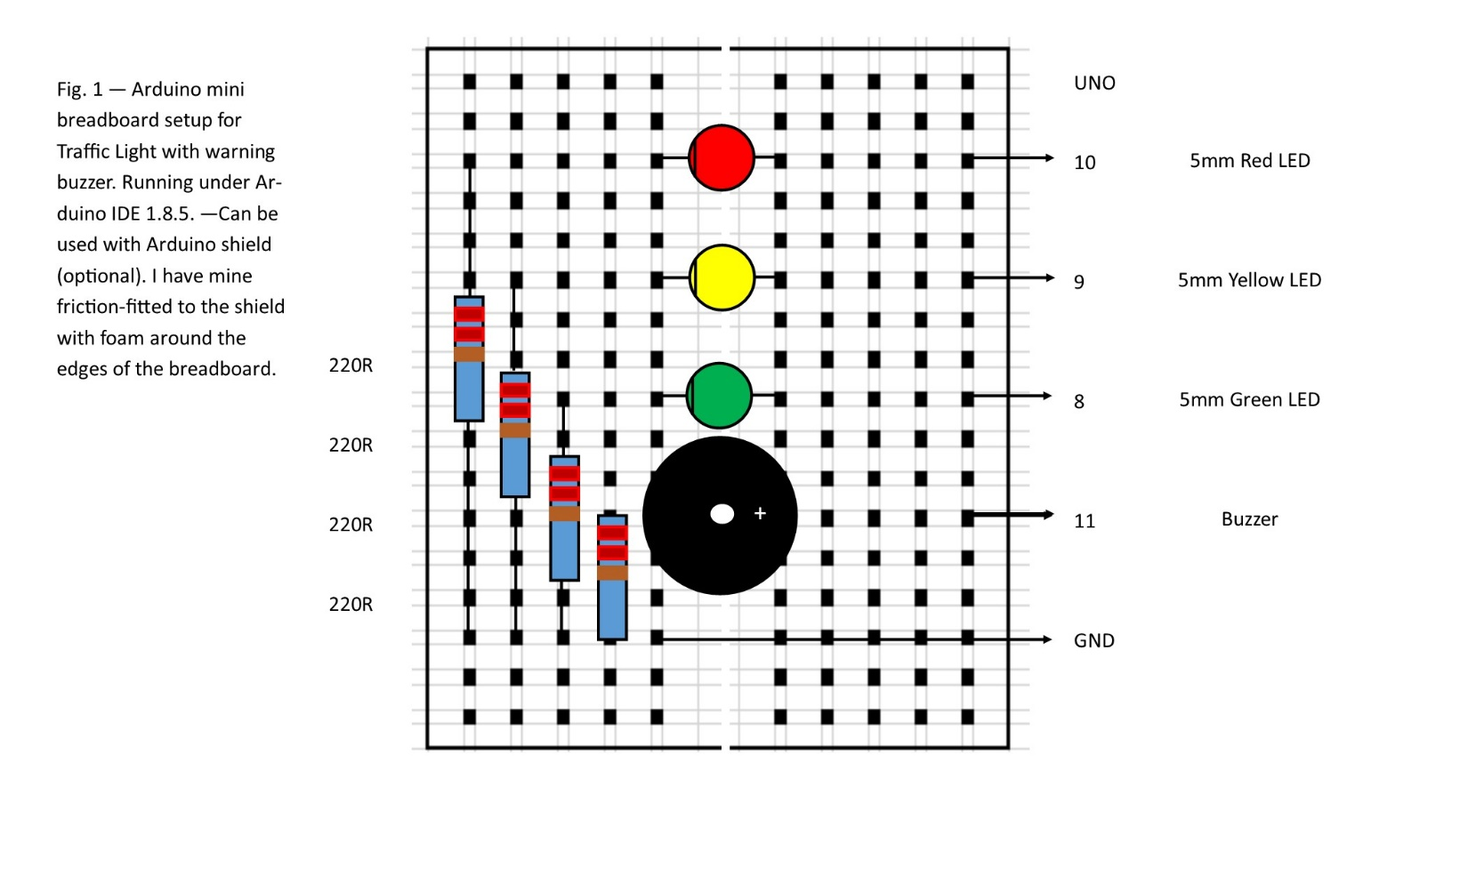

Code for Traffic Light

// Traffic light with warning buzzer for yellow light

// by Bill Jenkins

// this sketch simulates a traffic light's operation

// cycle is green -> yellow -> red

// it features a warning buzzer which sounds while yellow is lit

// Pin assignments for lights and buzzer

int RED = 10; // red light

int YELLOW = 9; // yellow light

int GREEN = 8; // green light

int BUZZER = 11; // buzzer

// Variables for warning buzzer

int PITCH = 193; // tone (G3) for yellow light warning

int CYCLE = 400; // pitch time in milliseconds

int i; // loop counter - how many times to repeat the warning sound

// the setup function runs once when you press reset or power the board

void setup() {

// initialize digital pins for red, yellow, green and buzzer as an output.

pinMode(RED, OUTPUT);

pinMode(YELLOW, OUTPUT);

pinMode(GREEN, OUTPUT);

pinMode(BUZZER, OUTPUT);

}

// the loop function runs over and over again forever

void loop() {

// green light = 8 sec.

digitalWrite(RED, LOW);

digitalWrite(YELLOW, LOW);

digitalWrite(GREEN, HIGH);

delay(8000);

// yellow light = 4 sec., sound warning buzzer

digitalWrite(RED, LOW);

digitalWrite(YELLOW, HIGH);

digitalWrite(GREEN, LOW);

for (i=0; i<4; i++) {

tone(BUZZER, PITCH);

delay(CYCLE);

tone(BUZZER, PITCH*2);

delay(CYCLE);

}

tone(BUZZER, PITCH*4);

delay(CYCLE);

noTone(BUZZER);

delay(CYCLE);

// red light = 8 sec.

digitalWrite(RED, HIGH);

digitalWrite(YELLOW, LOW);

digitalWrite(GREEN, LOW);

delay(8000);

}